js me dependencies handle npm karta he

php ke liye composer

composer install --ignore-platform-reqs

npm add -D sass

@yield to fetch

@include to include content of page

composer create-project laravel/laravel first-app

composer install --ignore-platform-reqs

what is box-sizing: border-box;

why we use robots.txt

what is versioning in js and css?

Build tool help karta he production ready banana ke liye file ko

Example webkit perspective etc , isko vendor prefix bolte he

Build tool ko run karne ke liye npm run dev use karte he

Dev command package.json se aati he scripts section me se

Compress hone ke baad jo bhi space wagera hat ta he wo sab public folder me savehota he

Page banana ke baad usko route bhi karn ahota he web.php me

Feature branch for adding new feature branch

Vite config.js me bhi location dena rehta he

Deploy karne se pehle build karte he fir optimized code launch hota he

Package.lock.json me node ke liye rehta he

Use mixins in scss for optimization

transitions in css ? and it types.

Images all in public and add via asset function {{}}

<img src="{{ asset('images/download.jpeg') }}" class="card-img-top" alt="...">

Study CDN working

Include welcome blade php

Best way bootstrap me add karlo blade file me, not with link

Nvm node version manager , node ke version ko change karne me help karta he

Use vite and scss use @ best practices , do not use css

Always extend the welcome blade in every file and add that in route in web.php and yield that page content inn welcome blade and make a section in every file that needs to be fetched

Add scss withextensions

Also after dev , build the page that will give errors , then add the file in vite

Npm run dev karne ke baad build karne k baad hi push karna he

Scss dev mode me file se fetch hota he aur build karte time assets me se fetch hota he

Css me images use kar rhe ho toh build karte time ports ka dhyan rakhna he

Codewars

Laravel se hum web apps bana skte he aur API’s bana skte he

Laravel MVC , model view control pattern ko follow karta he ,

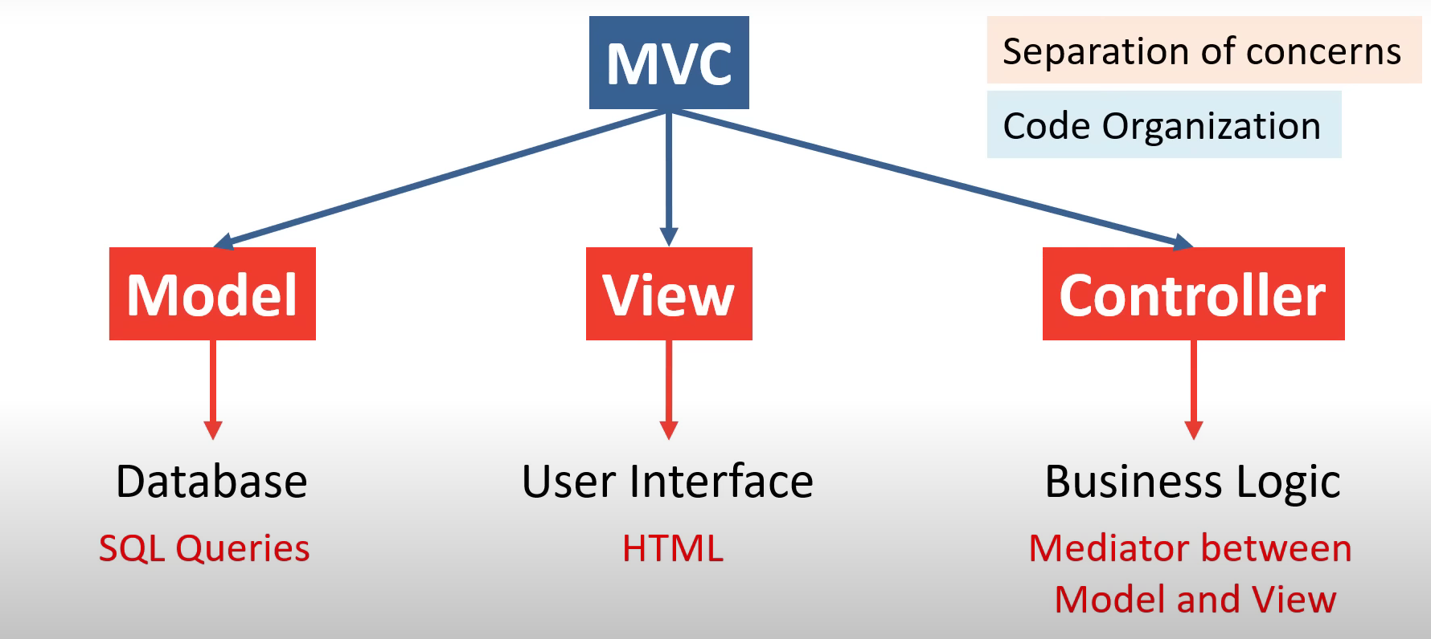

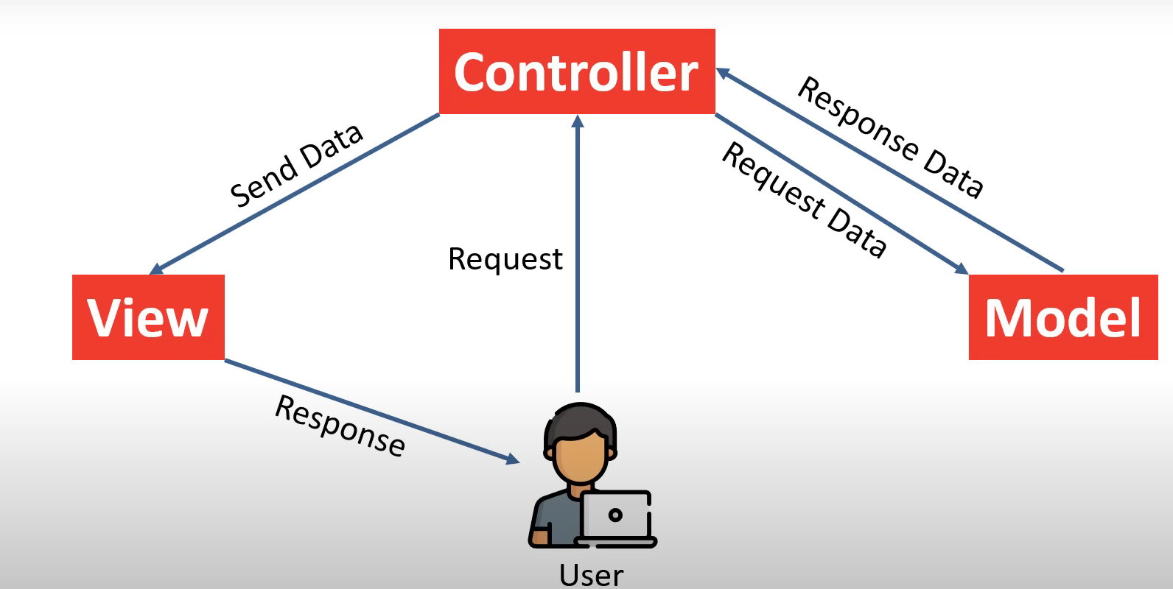

Id ko style nhi karna he uske liye alag se class banan he aur fir usko style karna he

Best practice to add css is to add class using the js functions like classlist , add and remove

Do not style css in the js function as it applies css inline in the html tags when inspected

Channels.php broadcasing msg ke liye use hota he

Console.php artisan command use karne ke liye use hota he

Web.php browser routes create hota he

Dependency injection

Dif branches for projects